***1.Bug Title:* Date shown in a wrong format DD/MM/YYYY**

***2.Severity :***

* **Medium**

***3.Reproducibility***

* **Always**

***4.Bug Type/Category***

* **UI**

***5.Steps to Reproduce***

* **Go to** [**https://qa-assessment.pages.dev/**](https://qa-assessment.pages.dev/)
* **Select a Date from the Calendar**

***6.Expected Results***

* **Date is suppossed to be shown in the format yyyy/mm/dd**

***7.Actual Results***

* **Date shown in the format dd/mm/yyyy**

***8.Screenshot/screenrecord link of bug***

**-screenShot**

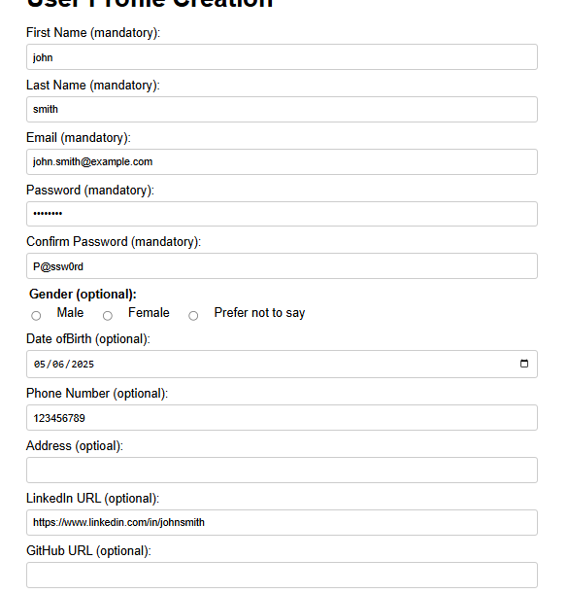

***9.Device Information***

**- Occurs on all Devices**

**-Connection type and speed: Mobile data / 17Mbps**